**LABORATORY EXERCISE 1**

**PROJECT PROPOSAL AND SYSTEM DESIGN**

# Learning Objectives

* Understand the initial phases of system development, including brainstorming and proposal creation.
* Develop skills in designing system architecture, modules, and workflows.
* Create an Entity-Relationship Diagram (ERD) to define database structures.

# Prerequisite student experiences and knowledge

Students should possess foundational knowledge of software systems and database concepts. Familiarity with diagramming tools for creating system designs and ERDs is helpful. Problem-solving skills for defining workflows and system requirements are also recommended.

# Background

Effective system development begins with thorough planning and design. A well-conceived project proposal ensures that system objectives align with user needs. Designing the system architecture and workflow provides a roadmap for development. The ERD visualizes how data will be stored, organized, and related within the system.

# Materials/Resources

* PC/Internet
* Diagramming Tools (Lucidchart, Draw.io, Microsoft Visio, DIA, etc.)
* Word-Processing Program (MS Word, Google Docs, etc.)

# Laboratory Activity

**Task 1: Brainstorming and Project Proposal**

1. Form a group of **4 students**.
2. Brainstorm potential system ideas, such as:
   * Inventory System
   * Point of Sale (POS)
   * Student Management Systems
3. Select a project idea that addresses an apparent problem or need.
4. Prepare a project proposal document containing the following:
   * **Title:** Name of the proposed system
   * **Problem Statement:** A brief description of the problem being addressed
   * **Objective:** Goals of the system
   * **Scope and Limitations:** Boundaries of the project
   * **Target Users:** Primary users and stakeholders
   * **Features:** Key functionalities

**Task 2: System Design**

1. Create a system architecture diagram to illustrate the components and their relationships.
2. Define the modules and workflows, detailing how users interact with the system.

**Task 3: Entity-Relationship Diagram (ERD)**

1. Identify the essential entities and relationships for the system.
2. Use a diagramming tool to create the ERD.
3. Ensure the ERD includes:
   * Entities with appropriate attributes
   * Primary and foreign keys
   * Relationships between entities

Deliverables

1. **Project Proposal Document:** Following the specified format
2. **System Design:** Architecture diagram and workflow description
3. **ERD:** Visual representation of the database design.

# Question

1. Explain the importance of creating a system design before starting development.

The importance of creating a system design before starting development is crucial for planning, organizing, and reducing mistakes. It provides clarity on system functionality, features, and connections, ensuring faster development and meeting user needs. Without it, developers may face confusion, delays, and increased costs.

1. Describe how the ERD helps in structuring the database design.

The ERD helps in structuring the database design by illustrating data relationships, identifying tables, fields, and their connections. It simplifies data storage, retrieval, and management, prevents errors like duplication, and enhances database efficiency, resulting in a well-structured and functional database.

1. What challenges did your group face during brainstorming and system design, and how did you address them?

Challenges did my group face during brainstorming and system design are conflicting ideas, difficulty in selecting the best approach, and understanding technical details. We address them by discussing ideas, weighing pros and cons, voting, researching, and seeking expert advice, the team collaborated effectively to overcome these challenges and successfully complete the system design.

**MONET – MONey Expense Tracker System**

**Problem Statement**

Managing personal finances effectively is a significant challenge for many individuals. Without a clear understanding of income, expenses, and spending habits, people often struggle to:

1. **Track Spending:** Many individuals lose track of where their money goes, leading to overspending and financial stress.
2. **Budget Effective:** Without a structured budgeting system, it’s difficult to allocate funds wisely and save for future goals.
3. **Save Consistently:** A lack of visibility into financial habits makes it hard to set and achieve savings goals.
4. **Avoid Debt:** Poor financial planning often results in accumulating debt, especially from credit cards or loans.
5. **Plan for Emergencies:** Many people are unprepared for unexpected expenses, which can lead to financial instability.
6. **Stay Organized:** Manually tracking expenses and bills is time-consuming and prone to errors.

**Objectives**

1. Track Spending Habits
2. Create and Stick to a Budget
3. Save for Specific Goals
4. Reduce Debt
5. Monitor Income and Expenses
6. Improve Financial Awareness
7. Plan for Large Purchases
8. Track Shared Expenses
9. Analyze Spending Trends
10. Achieve Financial Independence

**Scope and Limitations**

**Scope**

This money tracker project aims to help users monitor their daily expenses and income efficiently. It includes features such as adding transactions, categorizing expenses, generating reports, and setting budget goals. The system will be accessible through a mobile or web application for easy tracking.

**Limitations**

* The tracker will not support automatic bank synchronization.
* It will not handle multiple currencies in a single transaction.
* Data security will rely on user credentials without advanced encryption.
* The project will be limited to personal finance tracking and not for business accounting.

**Target Users**

1. **Budget-Conscious Individuals:** People who want to manage their money carefully and avoid overspending.
2. **Students:** Young people in school or college, often living on a tight budget.
3. **Young Professionals:** Individuals who have recently started their careers and are managing their own finances for the first time.
4. **Freelancers and Gig Workers:** People with irregular income, such as freelancers, contractors, or gig economy workers.
5. **Families and Households:** Families or groups of people sharing expenses such as couples or roommates.
6. **Travelers:** People who travel frequently, whether for work or leisure.
7. **Small Business Owners:** Entrepreneurs running small businesses or side hustles.
8. **Savers and Investors:** People focused on saving money or investing for the future.
9. **Tech-Savvy Users:** People who prefer using digital tools over traditional methods like spreadsheets or pen-and-paper tracking.
10. **Minimalists and Organizers**: People who value simplicity and organization in their lives.
11. **Global Users:** People who live, work, or travel internationally.

**Key Features**

**1. User Management**

* Users can register and manage their account details.
* Fields: user_id, username, email, password, created_at, updated_at.

**2. Expense Tracking**

* Users can log their expenses, categorize them, and associate them with a payment method.
* Fields: expense_id, user_id, category_id, pm_id, amount, description, expense_date.

**3. Income Tracking**

* Users can record income sources along with descriptions.
* Fields: income_id, user_id, amount, description, date, source.

**4. Recurring Transactions**

* **Recurring Expenses**: Users can set up automatic recurring expenses with frequency and next payment date.
* **Recurring Income**: Users can schedule recurring incomes, such as salary or passive income.
* Fields (RecurringExpense & RecurringIncome): rec_id, user_id, category_id, pm_id, amount, description, frequency, next_date, start_date, end_date.

**5. Budget Management**

* Users can allocate budgets for different spending categories within a specified time frame.
* Fields: Budget_id, user_id, category_id, amount, start_date, end_date.

**6. Category Management**

* Users can create and manage categories to organize their income and expenses.
* Fields: category_id, user_id, name, type (income or expense).

**7. Payment Method Management**

* Users can add and manage multiple payment methods (e.g., Credit Card, PayPal, Cash).
* Fields: pm_id, user_id, name.

**8. Timestamps for Transactions & Data Integrity**

* Each record includes created_at and updated_at fields to track when transactions are recorded and modified.

# Results/Output *(At least 2 sample)*

**MONET SYSTEM DESIGN**

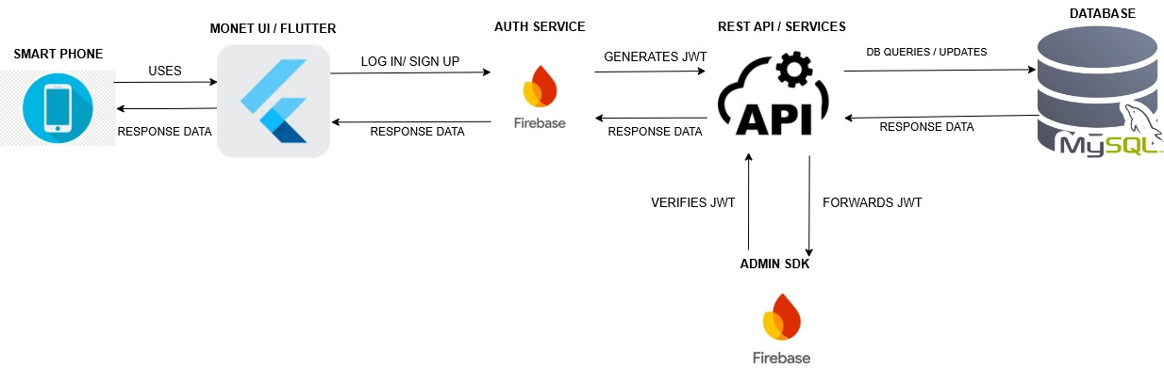

***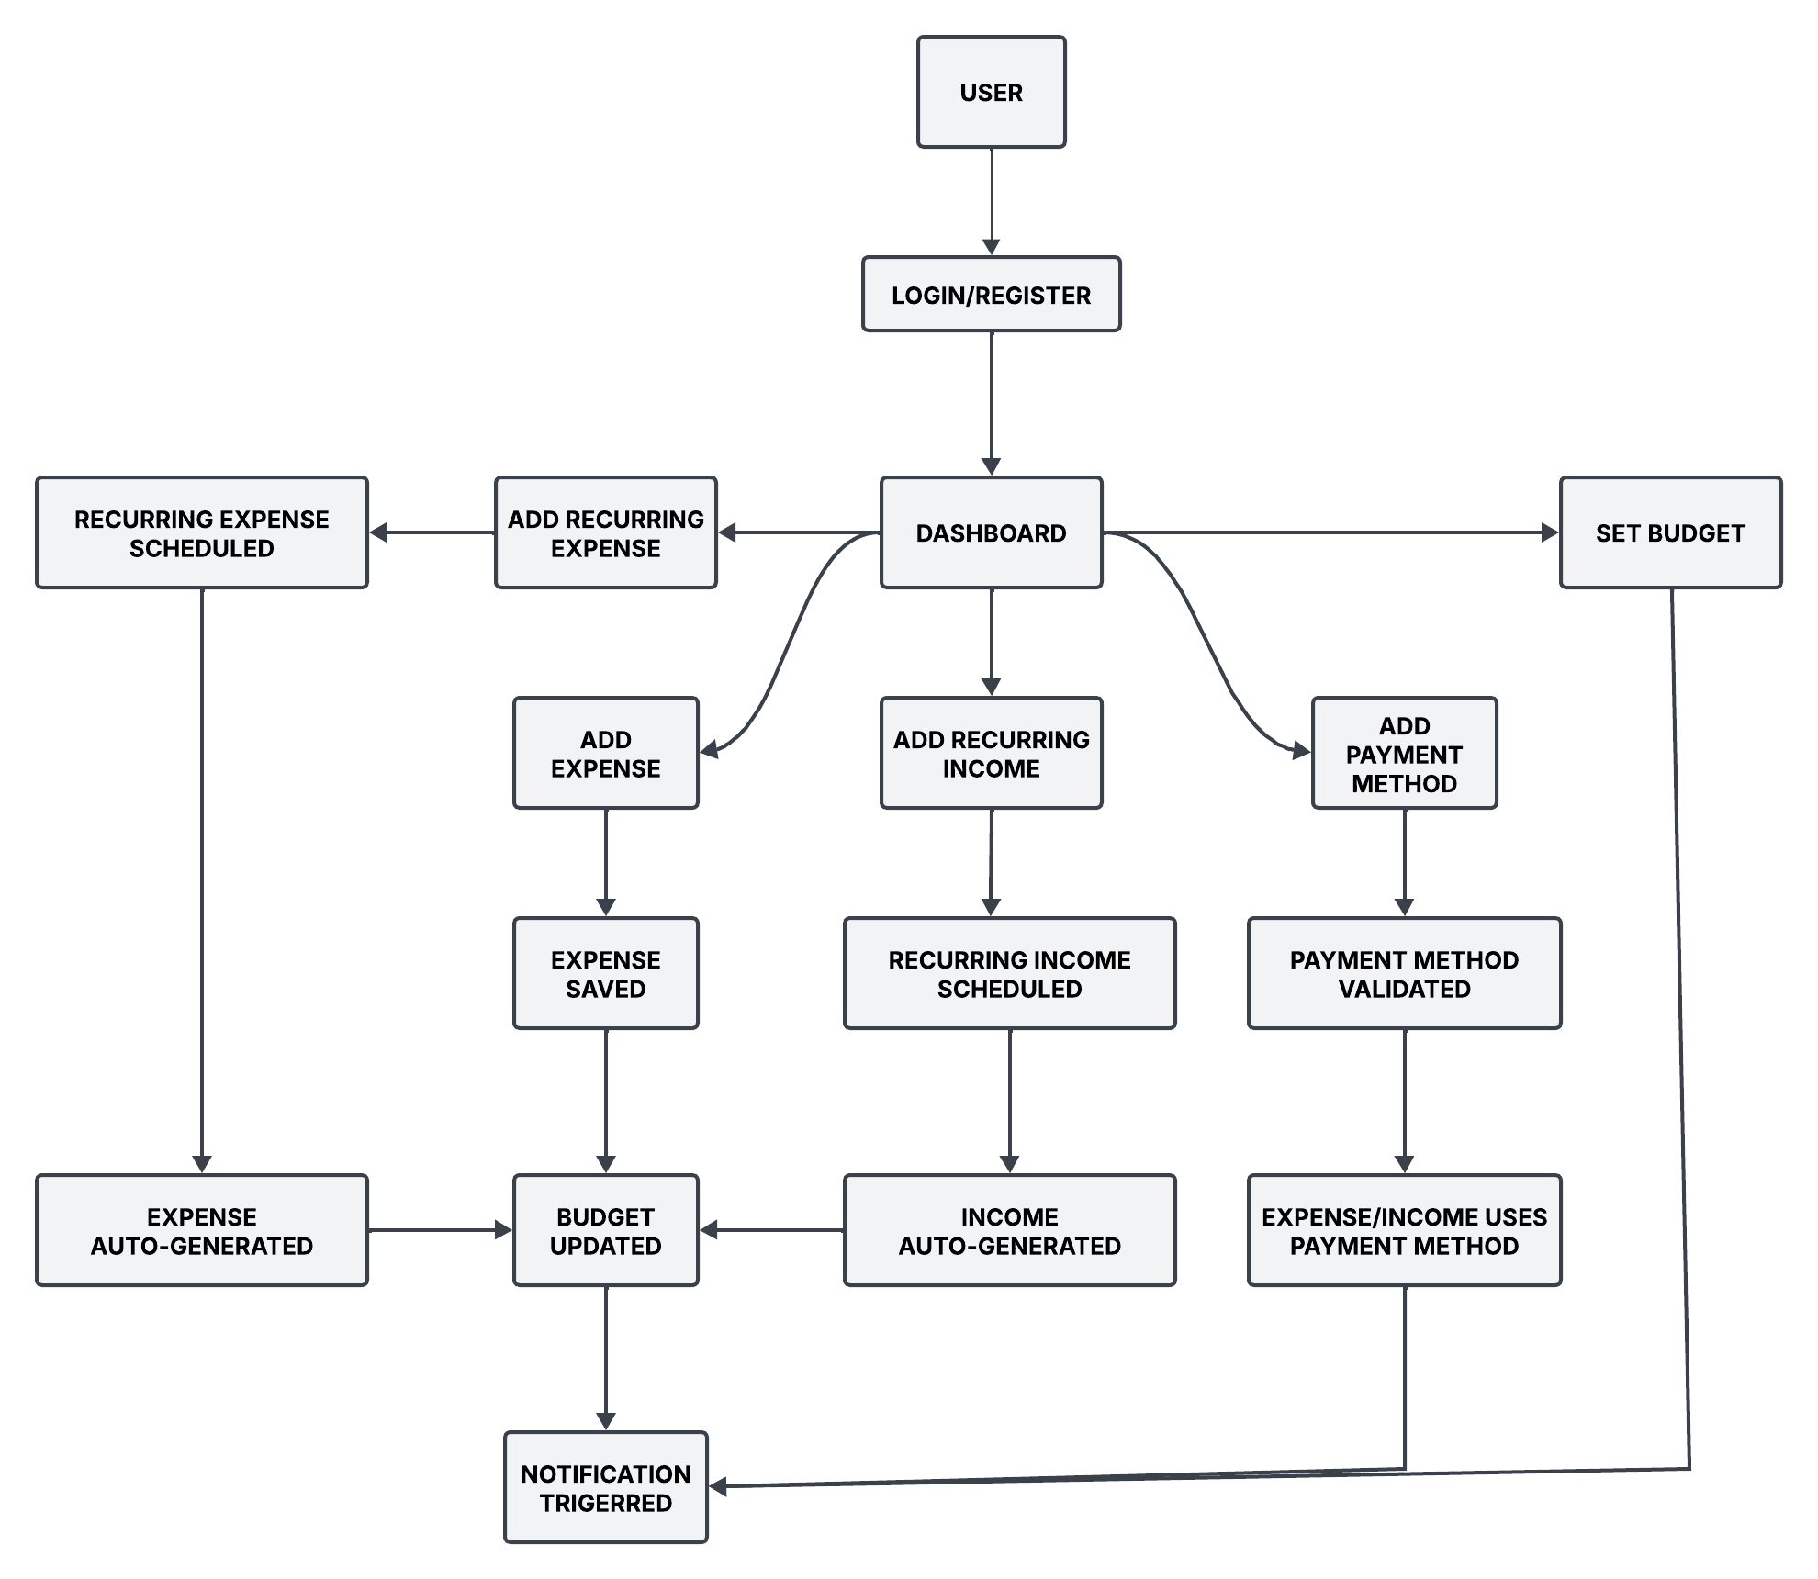*MONET WORKFLOW**

**MONET ERD**

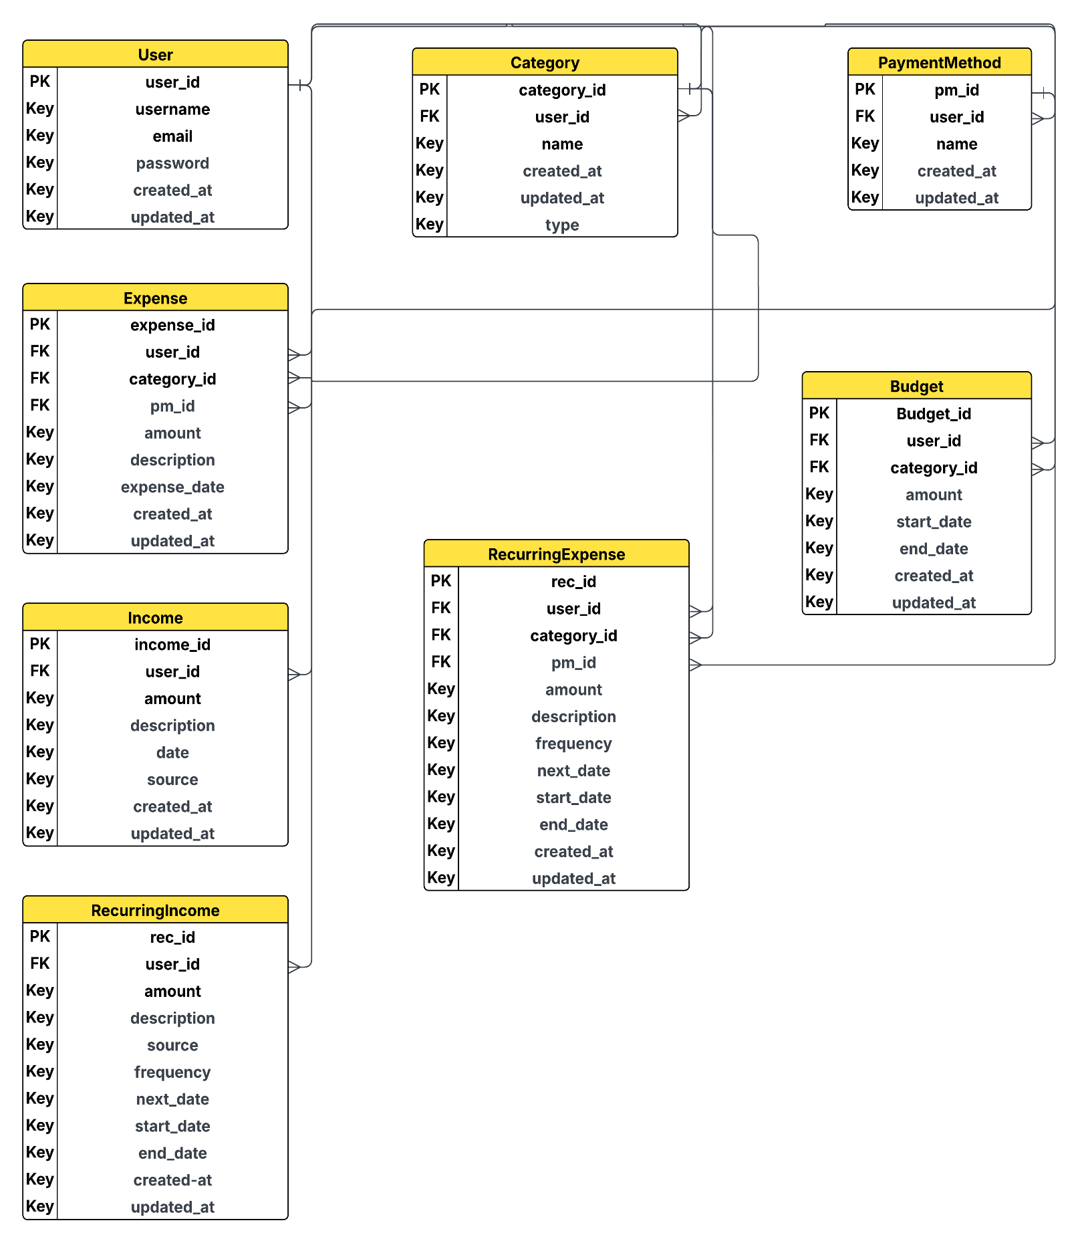

# Conclusion

In this group activity, we learned about the early stages of system development, which involve brainstorming ideas and creating proposals. We also developed important skills in designing the system's structure, modules, and workflows. These steps helped us understand how projects come together or begin.

Also, we created an Entity-Relationship Diagram (ERD) to define our database structures. This helped us understand how data is organized and how different parts of the system connect to each other.